**Ruth, a faithful friend**

**Reading: Ruth 1:6-10, 14-17**

Wile Naomi was in the country of Moab, she heard that the Lord had helped his people. He had given food to his people in Judah. So Naomi decided to leave the hill country of Moab and go back home. her daughters-in-law also decided to go with her.

Then Naomi told her daughters-in-law, “Each of you should go back home to your mother. You have been very kind to me and my sons who are now dead. So I pray that the Lord will be as kind to you. I pray that he helps each of you to find a husband and a good home.” Naomi kissed her daughters-in-law and they all started crying.

Then Orpah kissed Naomi goodbye, but Ruth hugged her and stayed. She said, “Don’t force me to leave you! Let me go with you. Wherever you go, I will go. Wherever you sleep, I will sleep. Your people will be my people. Your God will my God. Where you die, I will die and that is where I will be buried. I ask the Lord to punish me if I don’t keep this promise. Only death will separate us.”

**Thought about the reading**

Naomi was one of the people of Israel. She and her husband and two sons had left their homes and gone to live in Moab, because there was a famine in Israel and they could not get food to eat.

Then Naomi’s husband and two sons died. She was left on her own with her son’s wives. She decided to go back to her home in Israel and she told her daughters-in-law to go back to their own mothers. Orpah went but Ruth wanted to stay. She promised to stay with Naomi whatever happened.

Ruth was a good friend. She went with Naomi to a new home in Israel. She worked hard to find food for them both. God saw that she was a good friend and he looked after her and Naomi. At the end of the story, Ruth marries a man called Boaz and they have children.

Everything seemed to go wrong for Naomi and Ruth. Sometimes it feels like that for us too, but we can be sure that God is looking after us, just as he looked after Ruth. Jesus is the best friend we can have.

**Prayer**

Dear Jesus, thank you that you are a good friend, and you are always looking after me, even when everything goes wrong.

Please help me to be a good friend to other people.

Amen

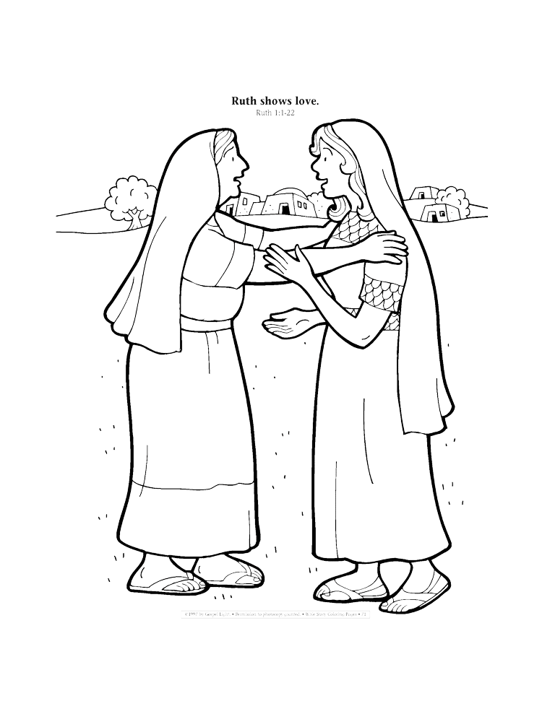

**Ruth**

**Cambridge Causeway**

Summer 2024

Bible Study notes

**Heroes of the Bible Part 2**

**3. Ruth, a good friend**

By Chrissy Cole